DIVIDE BY 5
KS1 – 2002 Paper
1.
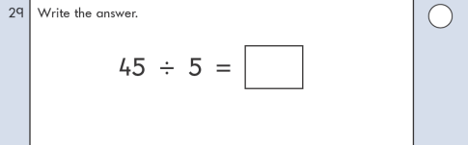
KS1 – 2016 Paper - Arithmetic
2.
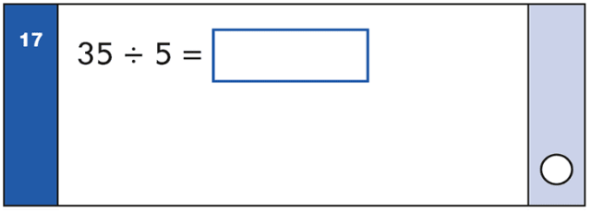
KS1 – 2016 Paper - Arithmetic (Second)
3.
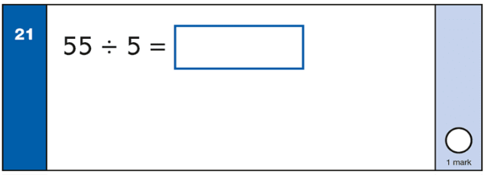

4.
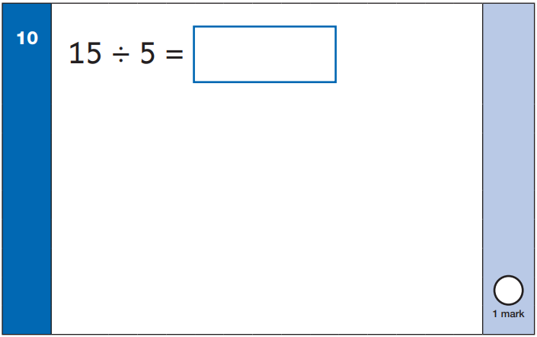
KS1 – 2022 Paper – Arithmetic
5.
